Exp7 fakat kapağını silmişim

The main purpose of this simulation project is to study and verify the operation of an electronic
circuit that has a specified function. The study includes simulation verification and hardware
implementation.
In this experiment, the purpose was to study the operation and verify the voltage gain relations of a common-source amplifier. To do this, we connected a circuit with a mosfet, resistors and capacitors. I provide all the experiment datas and LTSpice simulations related to it.

Part (1): Amplifier Voltage Gain
- First of all, we connected a circuit without the ac source, capacitors and the load resistor. We take VDD as 10 V, RD as 10 kΩ and RG as 10 MΩ. The circuit is:
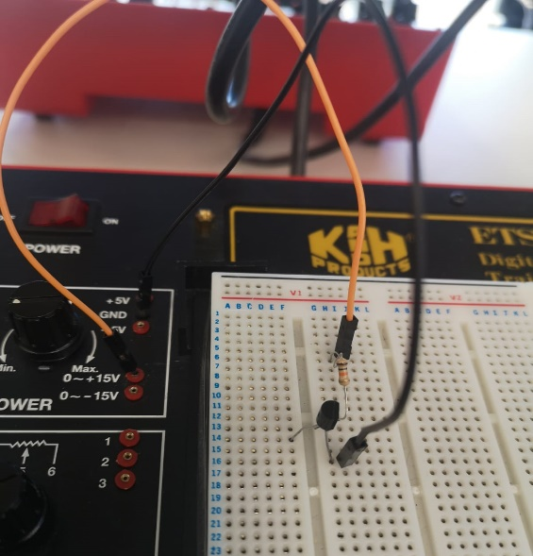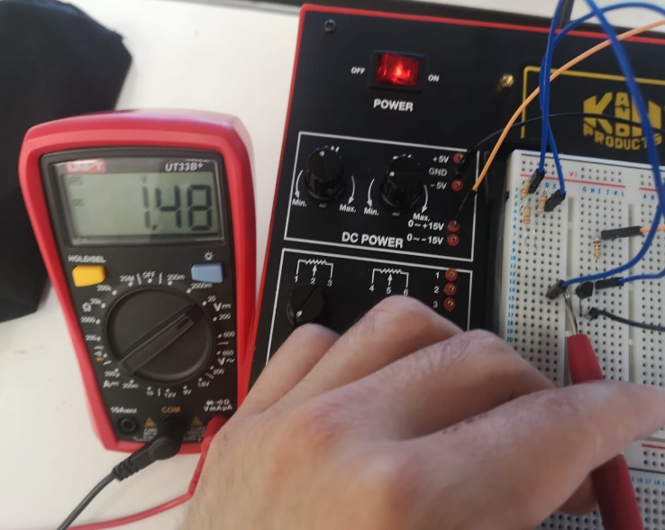
- Then I measure the voltages at the gate and at the drain. Both of them is 1.48V.
In order to find ID, we use this formula and the current at the drain is:
$$I_{D}=\frac{V_{D}}{R_{D}}= \frac{1.48 V}{10 kΩ}=0.148 mA$$

Here is the LTSpice simulation results:
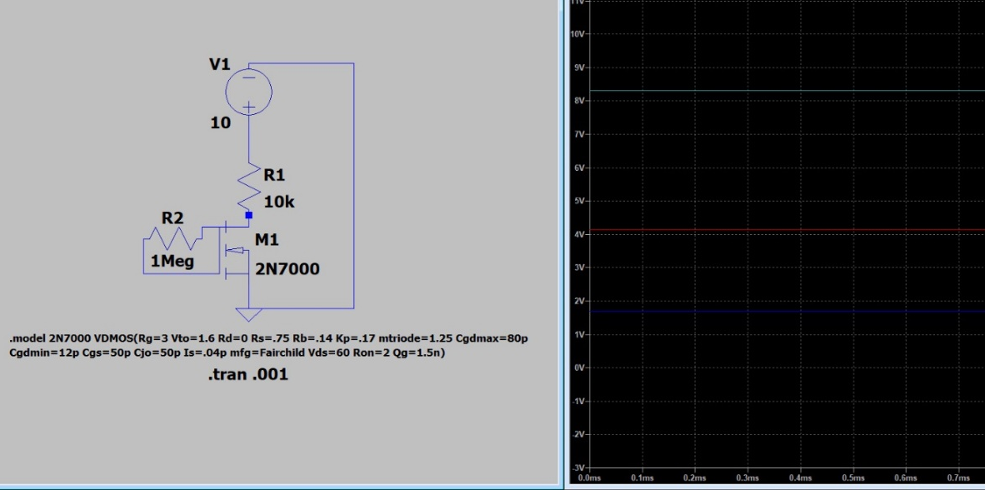

- Then, I add the capacitors and the load resistor RL (10 kΩ) and connect a sinusoidal ac source as Vsig. I arrange the frequency as 10 kHz and start to measure it with the input voltage as 400 mV.
- I connected the input and output signals to the two channels of oscilloscope. Here is the circuit connected and the LTSpice simulation:
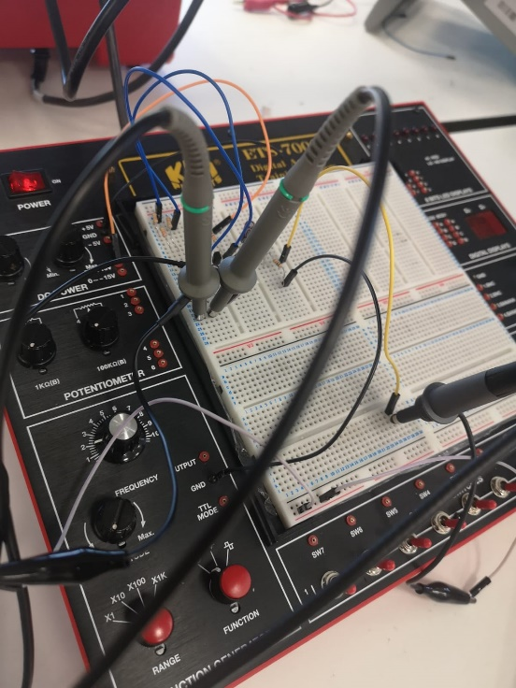
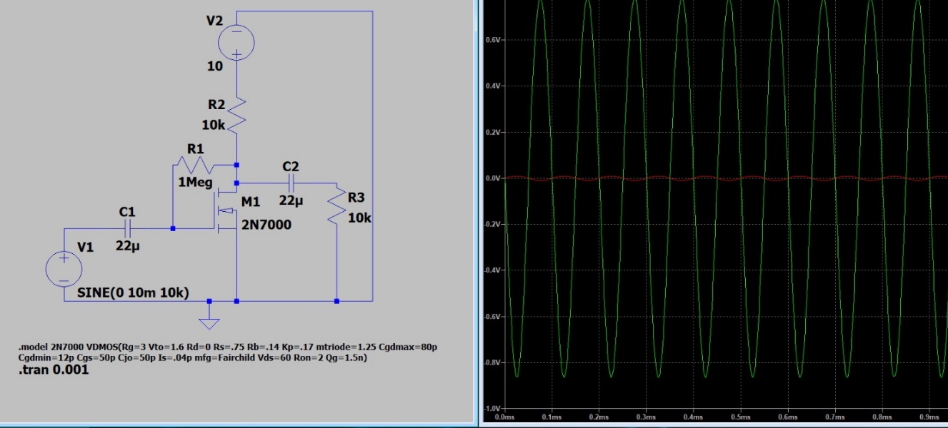
- I put voltage waveforms of input and output voltages.
- It says increase Vsig in steps of 10 mV but the minimum step was 200 mV so I started from Vmax = 400 mV which means average 200 mV. I took the results of Vmax at 400, 600, 800 mV’s and 1, 2, 3, 3.6 V respectively.
- I observe that output is distorted after input voltage of 3.6 V.

And I provide the results coming from two channels of the oscilloscope. The first channel connected to the Vsig and second one represents the output voltage.
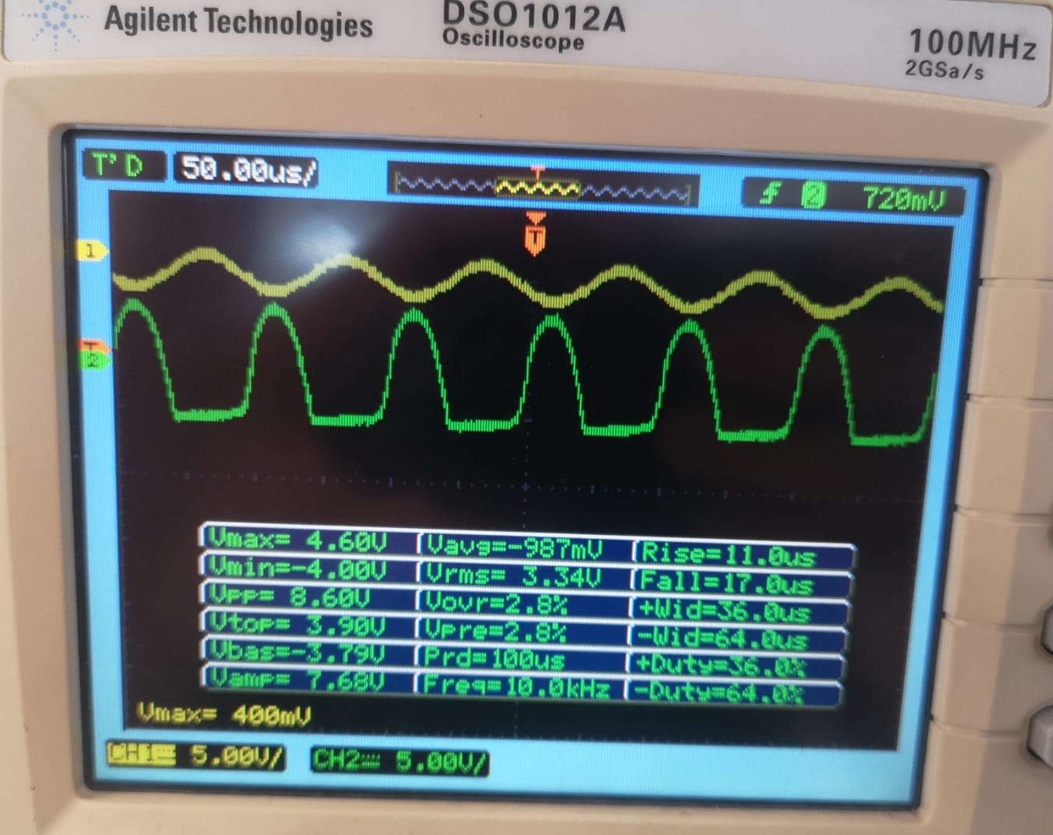
Figure 1. voltage waveforms of input and output at input voltage Vmax = 400mV
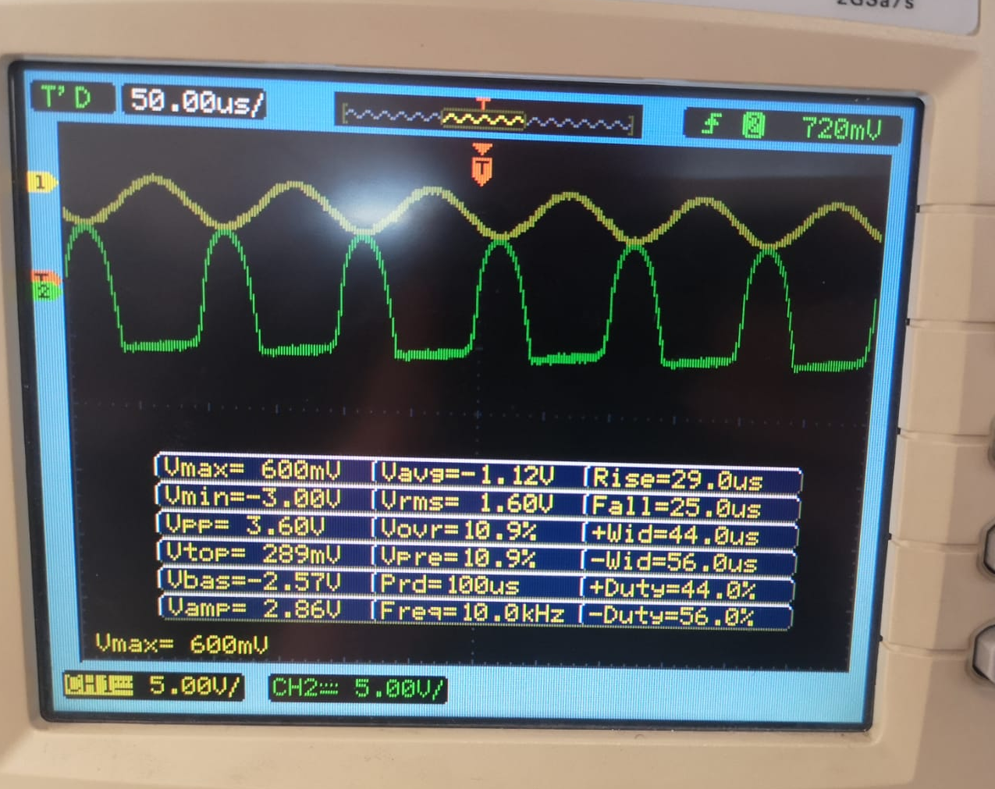
Figure 2. voltage waveforms of input and output at input voltage Vmax = 600mV

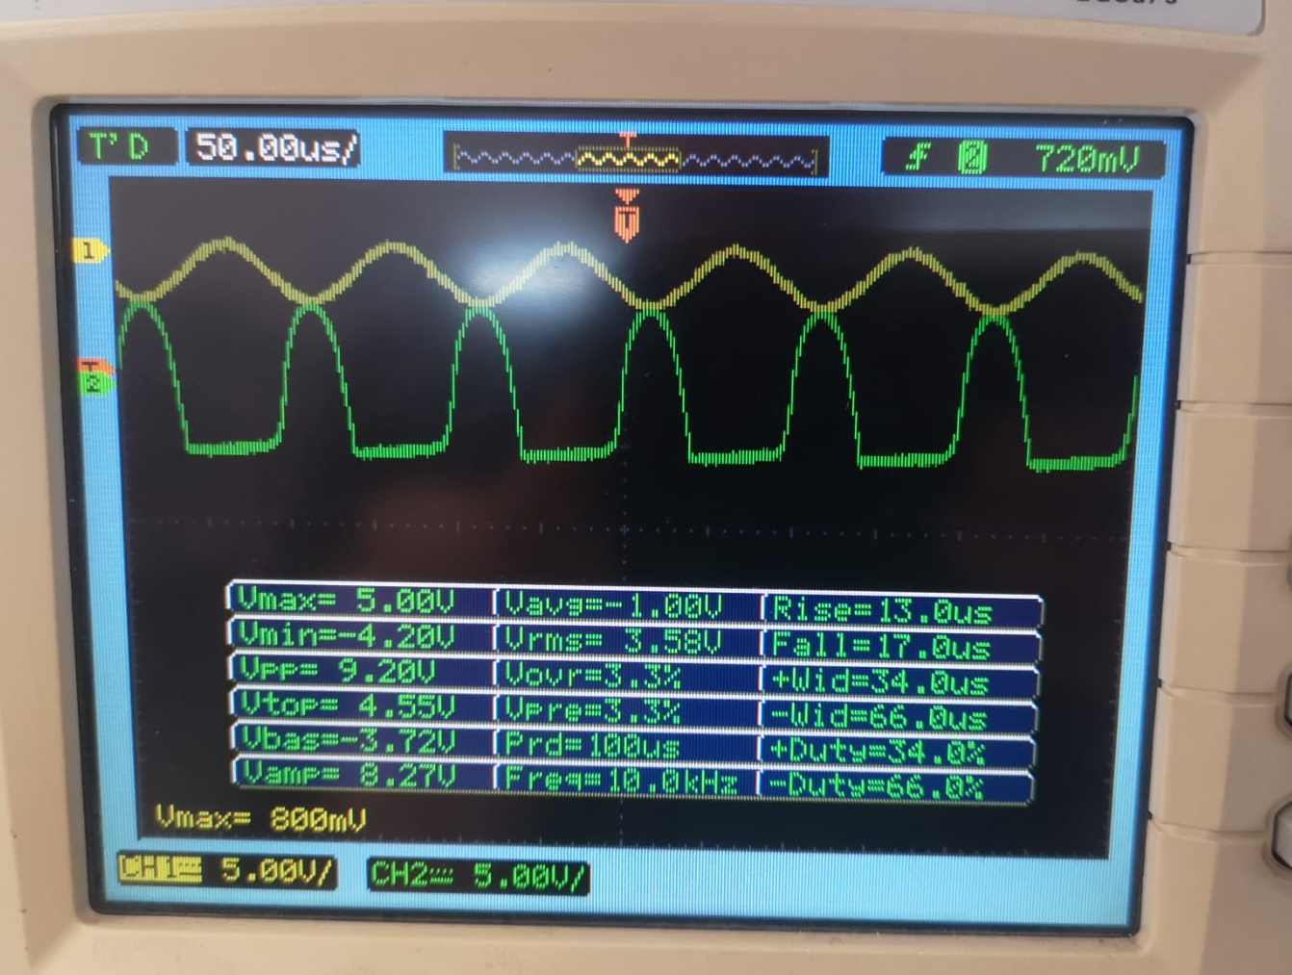
Figure 3. voltage waveforms of input and output at input voltage Vmax = 800mV

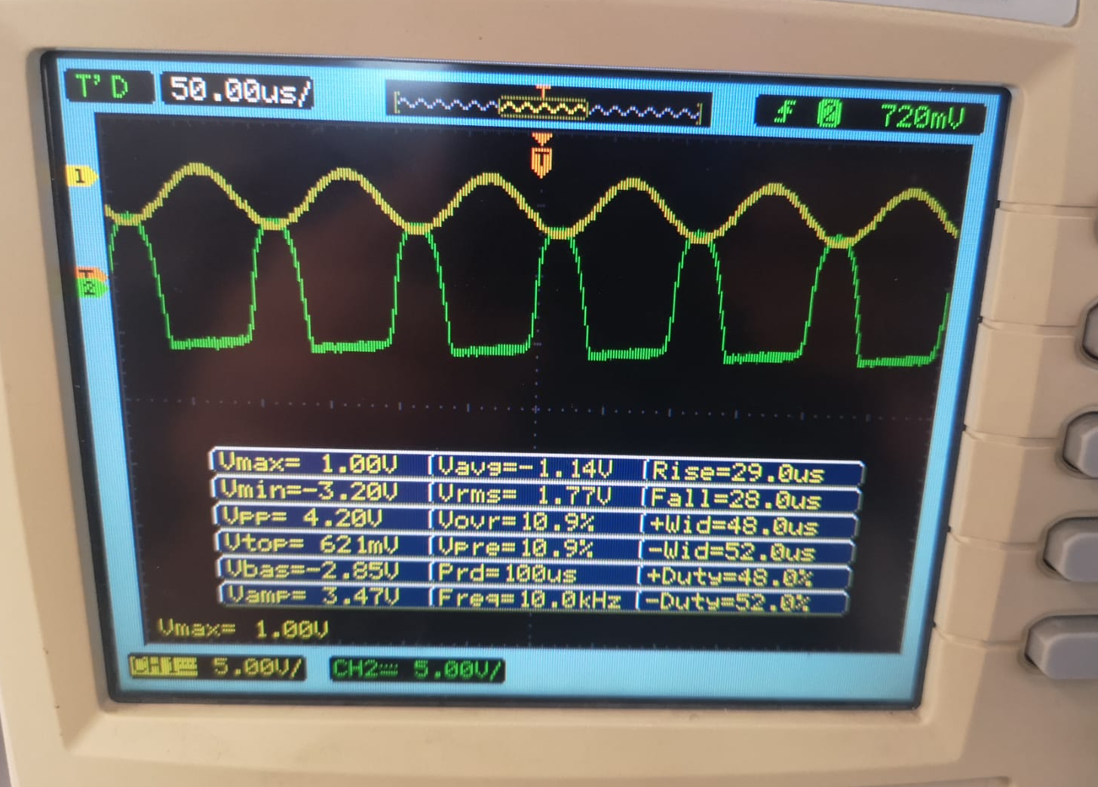
Figure 4. voltage waveforms of input and output at input voltage Vmax = 1 V

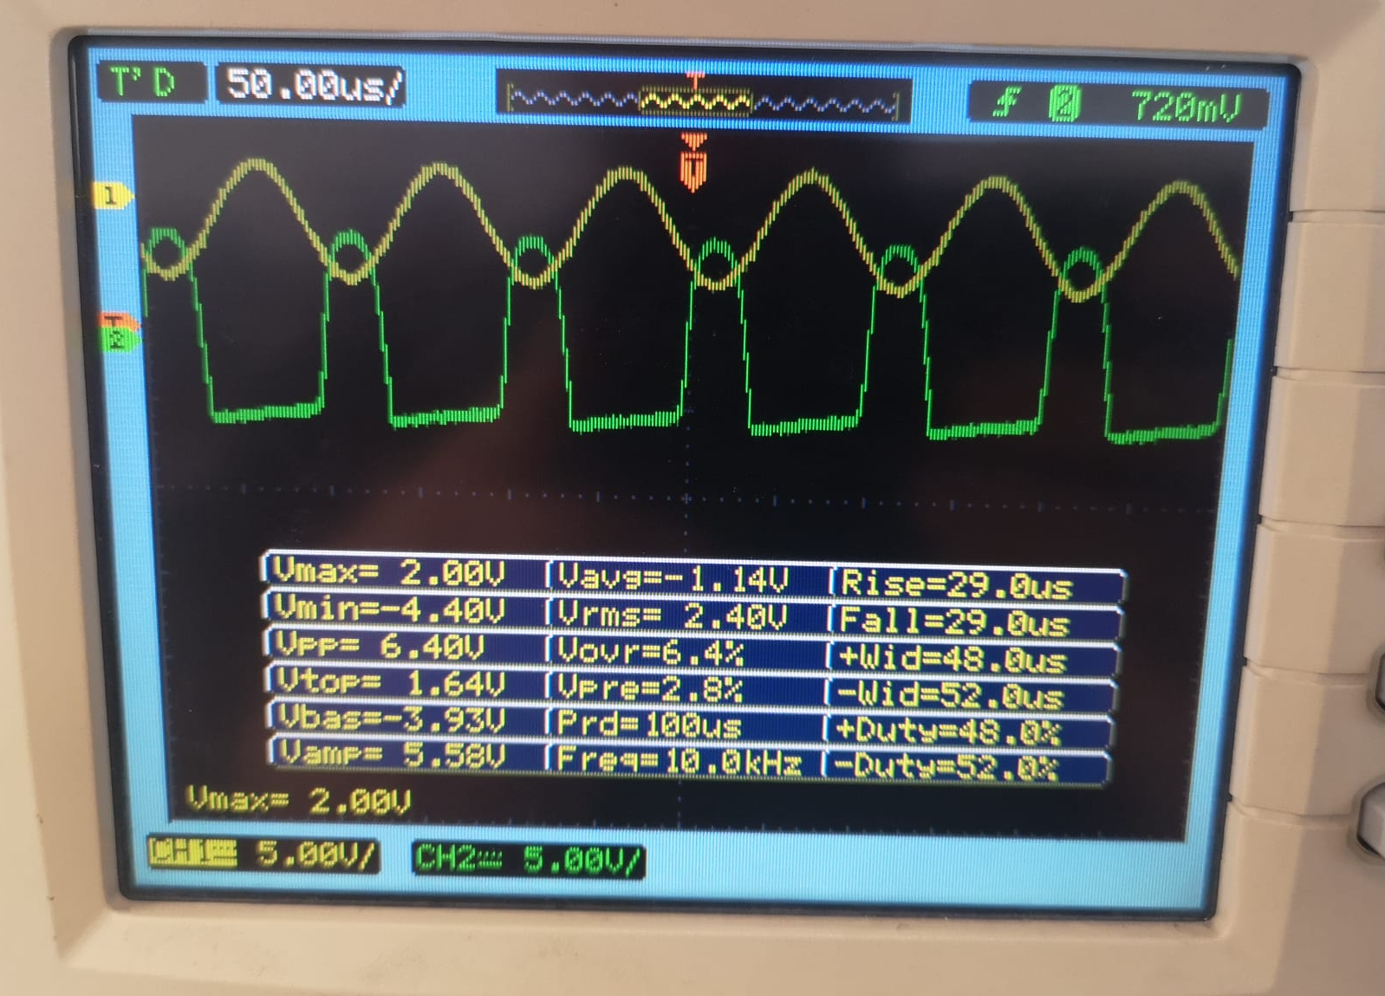
Figure 5. voltage waveforms of input and output at input voltage Vmax = 2 V

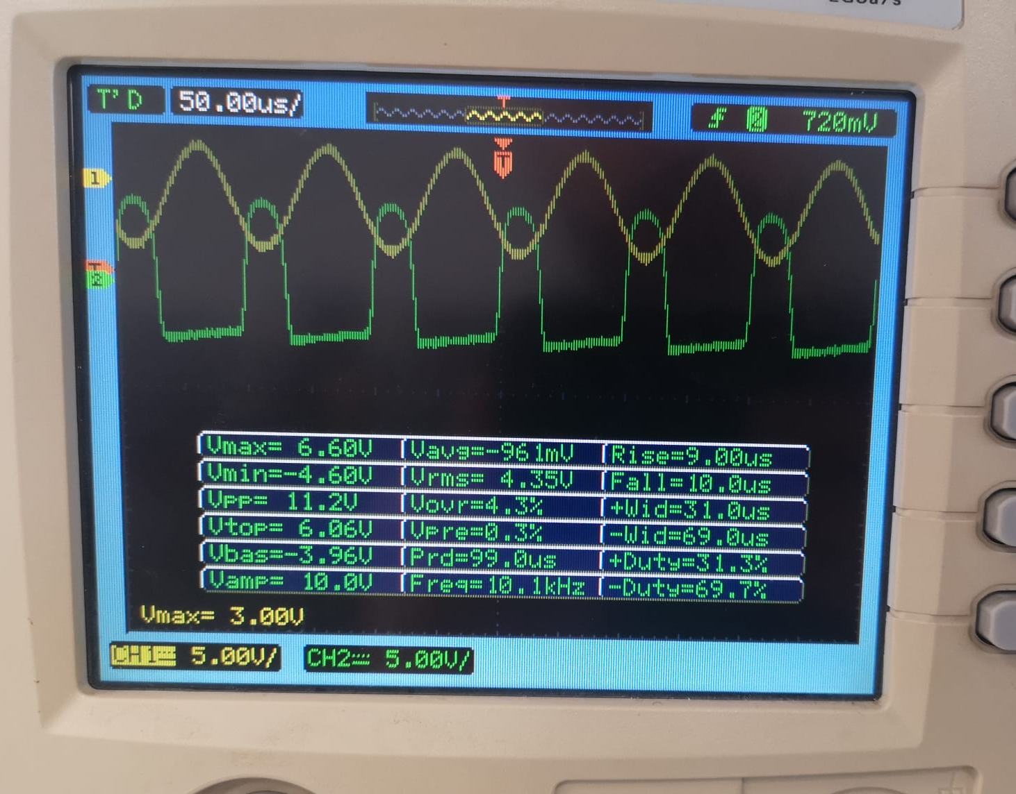
Figure 6. voltage waveforms of input and output at input voltage Vmax = 3 V

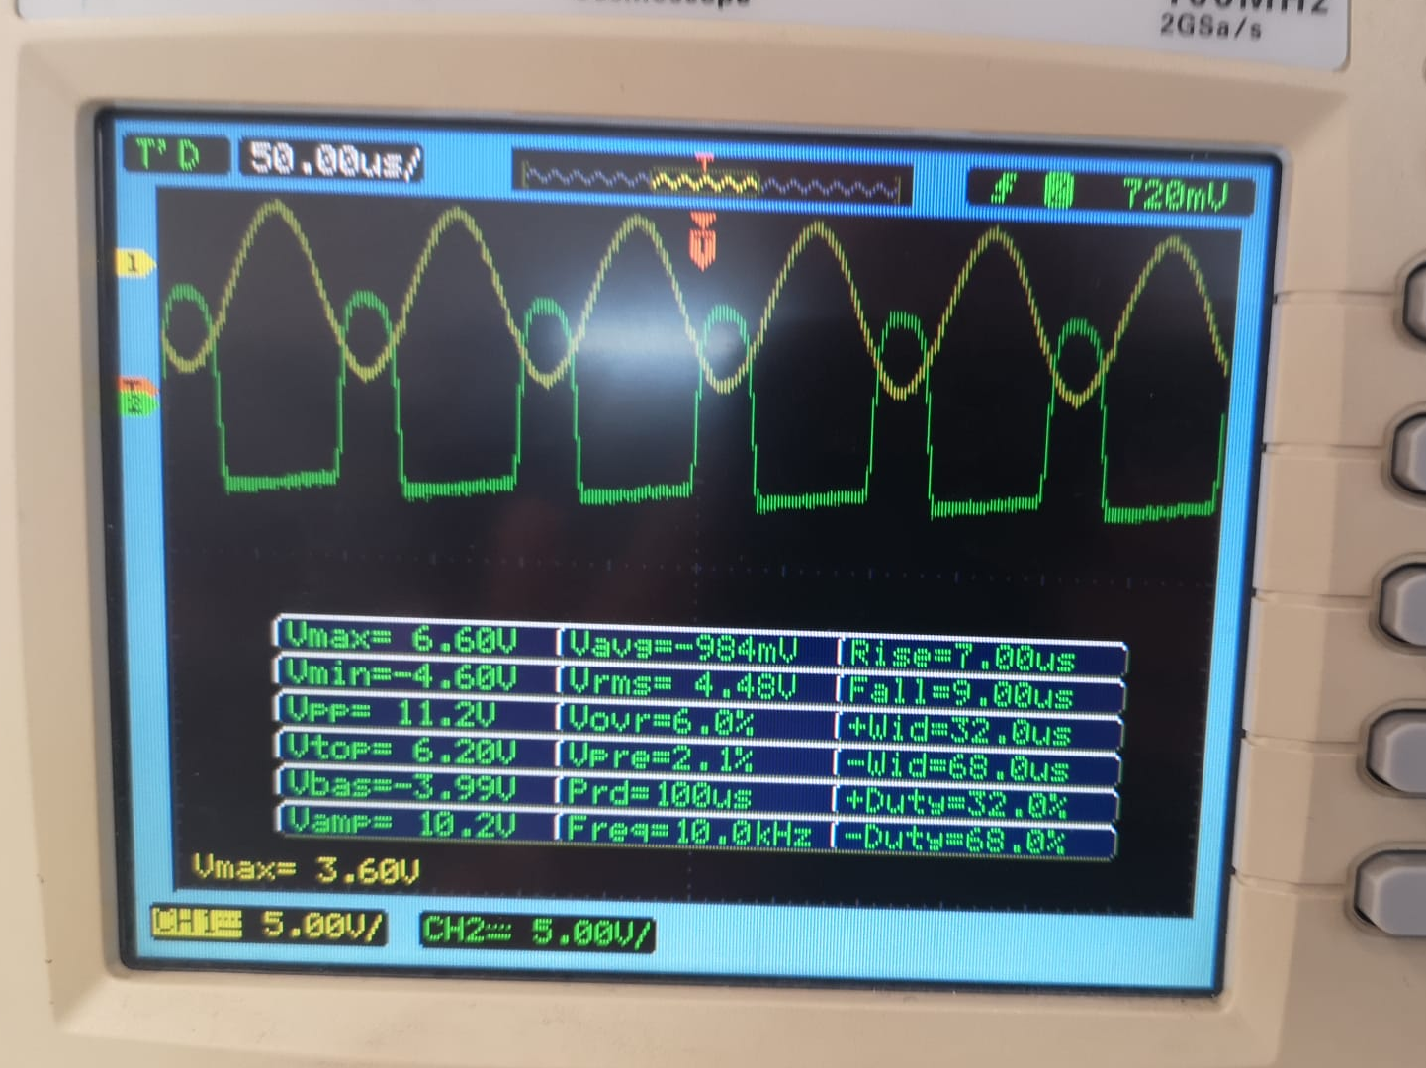
Figure 7. voltage waveforms of input and output at input voltage Vmax = 3.60 V

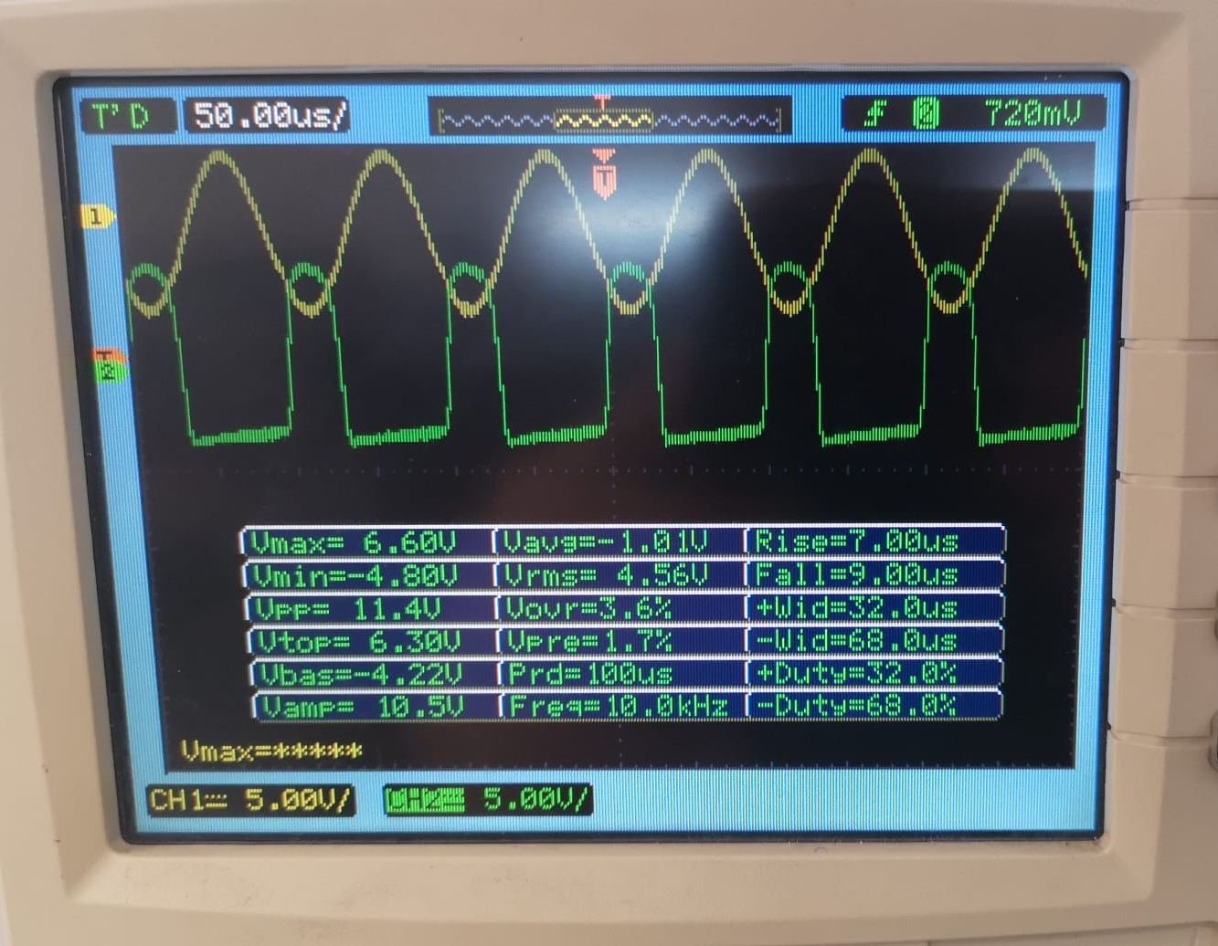
Figure 8. voltage waveforms of input and output at input voltage Vmax = 3.60 V+

Also, I provide the LTSpice simulation results:

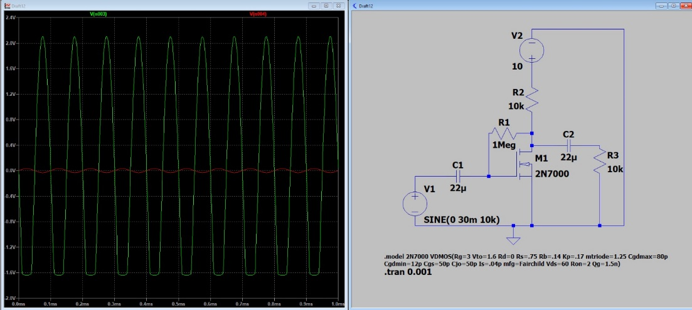
Figure 9. simulation results at 30 mV
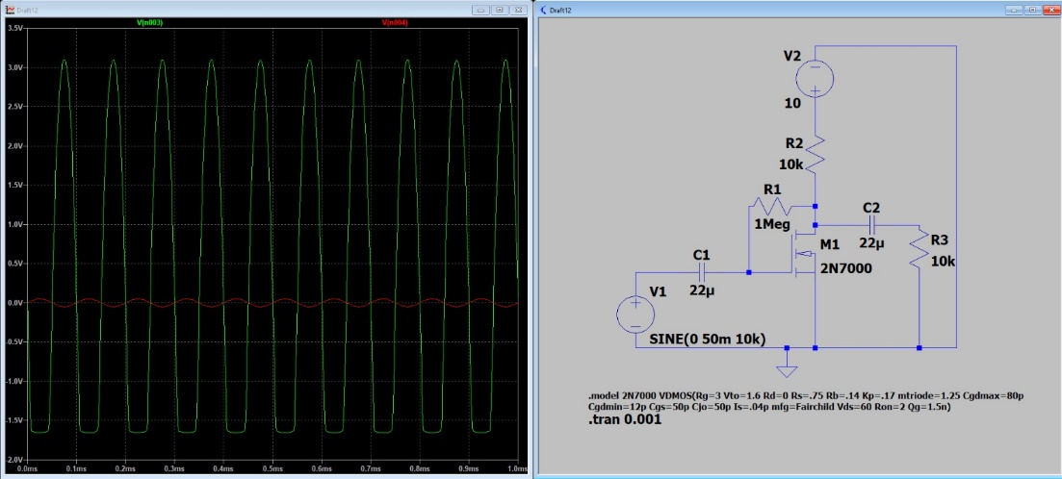
Figure 20. simulation results at 50 mV

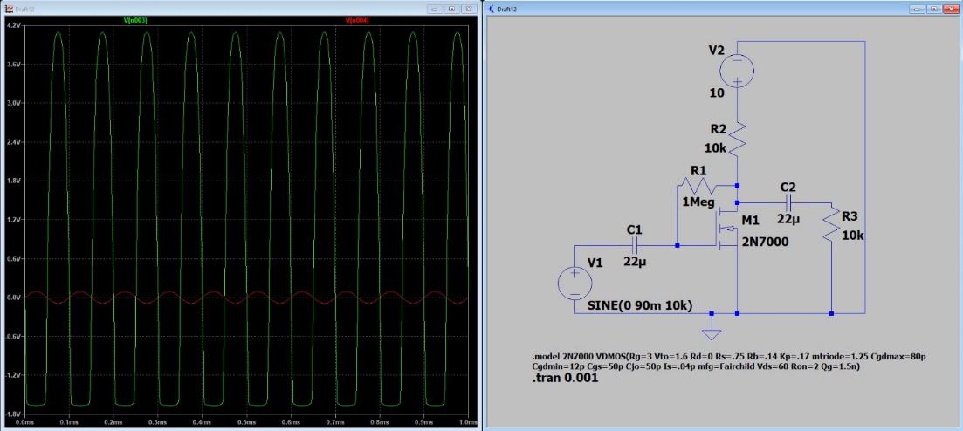
Figure 31. simulation results at 90 mV

Voltage Gain of the Amplifier

Amplitudes
Vsig (mV) | Vo (V) | Gain
200 | 7.68 | 38.4
300 | 7.9 | 26.3
400 | 8.27 | 20.675
500 | 8.6 | 17.2
1000 | 9.2 | 9.2
1500 | 10 | 6.67
1800 | 10.2 | 5.67

Table 2. Voltage Gain Results
About Linearity
Linearity depends on the operating region of MOSFET and the signal amplitude. For small signal amplitudes, the MOSFET operates in the saturation region where it can be approximated as a linear amplifier. However, as the signal amplitude increases, the MOSFET may enter the triode region or cutoff, causing distortion and reducing linearity.
Maximum Output Swing
The maximum output swing of the common-source amplifier is determined by the DC biasing point and the supply voltage 𝑉DD. The output voltage 𝑣𝑜 can swing from near the positive supply voltage 𝑉𝐷D​ to just above ground, but not all the way to ground due to the voltage drop across the transistor in the saturation region.
The maximum output swing can be approximated as:
$V_{out(max)}=V_{DD}-V_{DS(sat)}$ where VDS(sat) is the voltage drop across the drain resistor RD.
$V_{out(max)}=10-1.48=8.52 V$

Part (2): Input and Output Resistance of Amplifier
For the second part, I measure the voltages with and without the load resistor to find the output resistances.

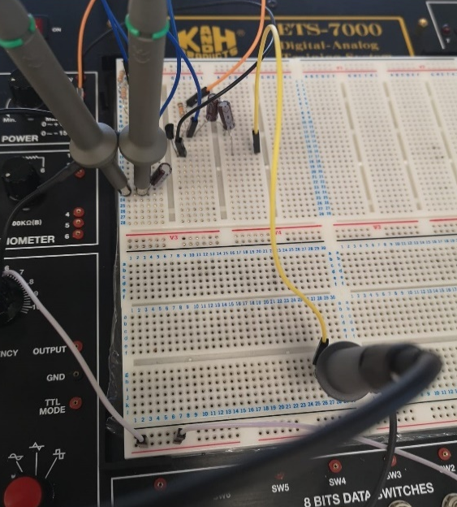

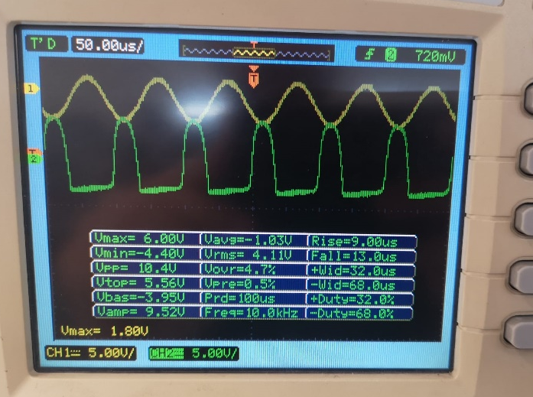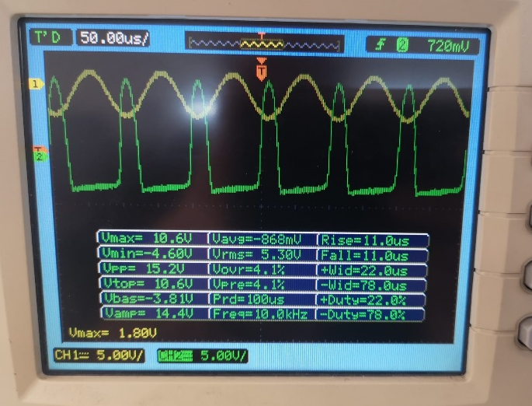

Figure 42. output waveforms with and without the resistor RL

Then I connect a resistor between the input voltage source and the coupling capacitor and measure the voltage gain with and without resistor.

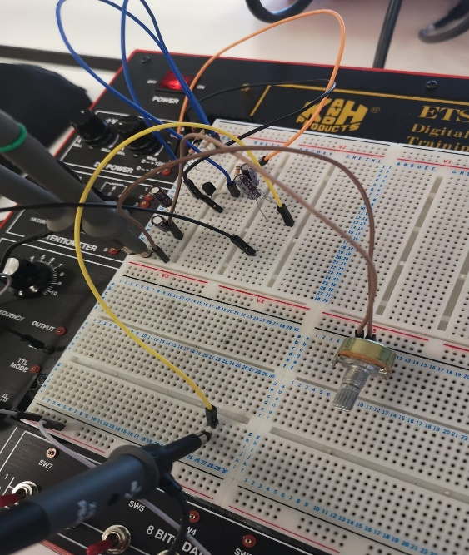

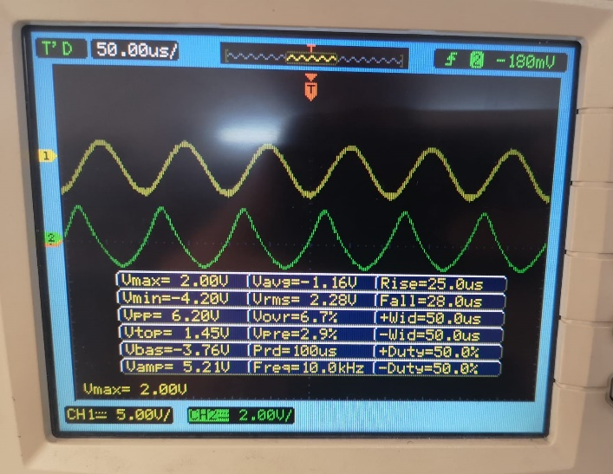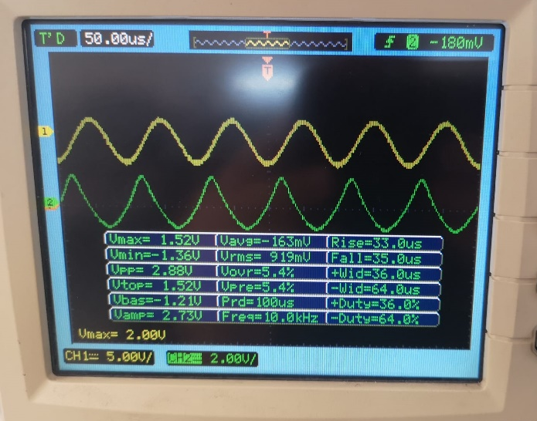

Figure 53. output waveforms with and without the resistor Rx
I record the results in table 3.
Output Resistance (kΩ) |  |  | Input Resistance (kΩ)
Gain with RL | Gain without RL | Ro | Gain with Rx | Gain without Rx | Ri
10.57 | 16 | $$5.13$$ | 11 | 2.73 | $$75.2$$

Table 3. Input/output Resistances
Output resistance can be found from the formula:
$R_{O}=R_{L}(\frac{Gain without R_{L}}{Gain with R_{L}}-1)$ = $10 kΩ \left(\frac{16}{10.57}-1\right)=5.13 kΩ$
And the input resistance can be found from the formula:
$R_{in}=R_{x}(\frac{Gain without R_{x}}{Gain with R_{x}}-1)$ = $100 kΩ \left(\frac{2.73}{11}-1\right)=75.2 kΩ$

Comments
-Common-source amplifier typically offers a high voltage gain due to the intrinsic gain of the MOSFET. In the circuit, I found high voltage gains and it satisfies characteristic of the common-source amplifier.
-Secondly, the I calculated the high input resistance comparing to the output.
-It was found the input and output resistances using RL and Rx.
-Ensuring the input signal remains within the linear range is crucial for accurate gain measurements. If the gain remains consistent and predictable within this range, it indicates that the amplifier is not entering the non-linear regions (triode or cutoff).

